- An emf of 25 mV is induced in a 100-turn coil when the current is changing at the rate of 10 A/s. ×

- Find the inductance of the coil. 5
A | B | C | D | E
2 mH | 2.5 mH | 3 mH | 3.5 mH | 4.5 mH

- What is the magnetic flux through each turn of the coil at an instant when the current is 5 A? 5
A | B | C | D | E
105μWb | 95μWb | 125μWb | 145μWb | 130μWb

- In the circuit shown in figure, let L = 5 H, R = 10 Ω, and ξ = 120 V.
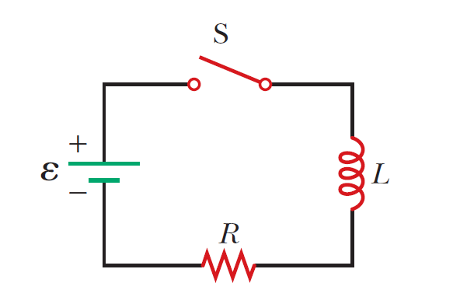

- What is the time constant of the circuit Ƭ? 5

A | B | C | D | E
50 s | 0.5 s | 2 s | 0.25 s | 4 s

- What is the self-induced EMF after a time interval equal to one time constant the switch is closed (switching on)? e=2.5 5

A | B | C | D | E
72 V | 120 V | 48 V | 52 V | 60 V

- What is the value of the final steady-state current I_{max}? 5

A | B | C | D | E
10 A | 11 A | 9 A | 12 A | 13 A

- The switch in figure is connected to position a for a long time interval. At t=0, the switch is thrown to position b. (C=10 μF, L=0.1 H, ξ=12 V) After this time, what are… ×

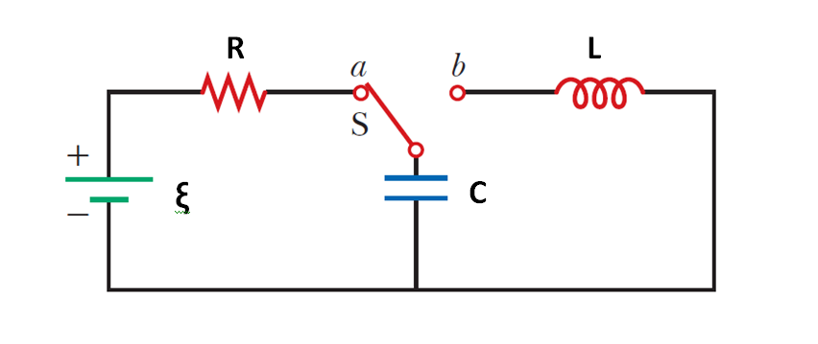

a) the cyclic frequency ω of oscillation of the LC circuit (in rad/s)? 5

A | B | C | D | E
980 | 850 | 1100 | 200 | 1000

b) the maximum charge that appears on the capacitor? 5

A | B | C | D | E
110 μC | 120 μC | 100 μC | 90 μC | 80 μC

c) the maximum current in the inductor? 5

A | B | C | D | E
110 mA | 100 mA | 90 mA | 120 mA | 130 mA

- Two capacitors with capacitances of C₁ = 2 μF and C₂ = 3 μF are connected in series to an alternating current circuit with a voltage of 200 V and a frequency of 50 Hz (π=3). Find:

a) the intensity of the current in the circuit, 5
A | B | C | D | E
52 mA | 62 mA | 72 mA | 82 mA | 50 mA

b) the potential drop across the first and second capacitors. 5
A | B | C | D | E
U₁=120V  U₂=80V | U₁=80V  U₂=120V | U₁=100V  U₂=80V | U₁=80V  U₂=100V | U₁=110V  U₂=90V

- The voltage phasor diagram for a certain series RLC circuit is shown in figure. The resistance of the circuit is R=20 Ω, and the frequency is f=60 Hz (U_{L}= 50V, U_{R} = 40V, U_{C} = 20V). Find: ×
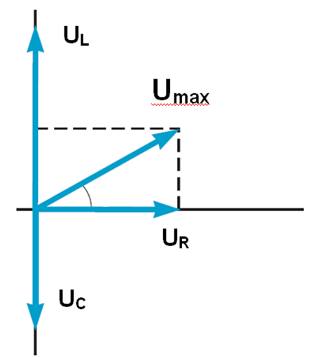

- the maximum voltage U_{max}, 5

A | B | C | D | E
30 V | 20 V | 110 V | 50 V | 60 V

- the maximum current I_{max}, 5

A | B | C | D | E
2 A | 0.5 A | 2.5 A | 1 A | 1.5 A

- the impedance Z, 5

A | B | C | D | E
22 Ω | 25 Ω | 26 Ω | 30 Ω | 35 Ω

- the capacitance C, 5
__________________

- the inductance of the circuit L 5
__________________

- A beam of light both reflects and refracts at the surface between air (n_{air}=1) and glass as shown in figure. An incidence angle is θ, and the reflected and the refracted ray perpendicular to each other (c – light speed in vacuum). Find ×
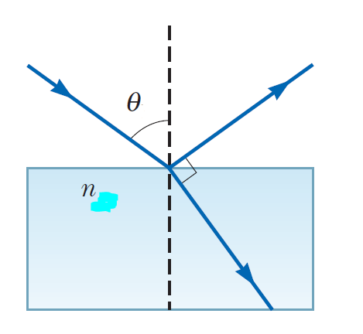
- the refractive index of the glass n 5
A | B | C | D | E
sinθ | Cosθ | tanθ | cotθ | tan^{–1} θ
- light speed in the given glass v 5
A | B | C | D | E
c·cotθ | c·sinθ | c·cosθ | c·tan²θ | c/cosθ

- An object is placed d_{o}=50 cm from a concave spherical mirror with focal length of magnitude f=20 cm.

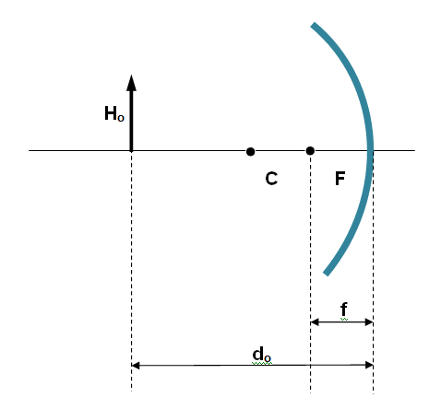

a) Find the location of the image. 5
b) What is the magnification of the image? 5
c) What is the radius of curvature of the mirror? 5

A | B | C | D | E
30 cm | 50 cm | 10 cm | 20 cm | 40 cm

- A small spherical insulator of mass m and charge q is hung by a thread of negligible mass. A charge of q′ is held d away from the sphere and directly to the right of it, so the thread makes an angle θ with the vertical (see the drawing). Express: +
a) the angle θ -5-
b) the tension T -5-

in terms m, q, q′ and d.

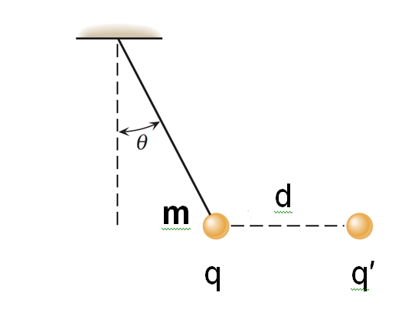

- The drawing shows an edge-on view of two planar surfaces that intersect and are mutually perpendicular. Surface 1 has an area of A₁ = 1 m², while surface 2 has an area of A₂ = 3 m². The electric field in the drawing is uniform and has a magnitude of E=200 N/C (θ=30°). Find the magnitude of the electric flux through

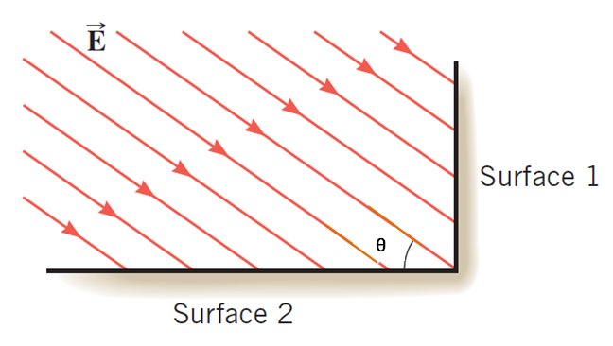

a) surface 1 -5-

b) surface 2 -5-
3. A sphere with a radius of 1 m is charged to a potential of 30000 V (π=3, ε_{o}=8·10^{–12} C²/N·m²). Find the: +

- energy of the charged ball W -5-

- surface charge density σ. -5-

- Consider the circuit shown in figure where R₁ = 10 Ω, R₂ = 10 Ω, R₃ = 5 Ω, R₄ = 2 Ω, R₅ = 3 Ω, and ε = 24V Find:
a) the current in the R₅ resistor; -5-

b) the potential difference between points -5-
a and b.

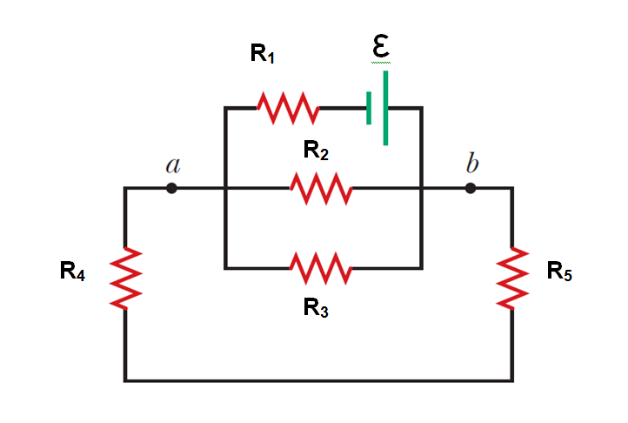

- A particle has a charge of +1 mC and is located at the coordinate origin. As the drawing shows, an electric field of E_{x} = 200 V/m exists along the +x axis. A magnetic field also exists, and its components are B_{x}=1.5 T and B_{y} = 1 T. Calculate the magnitude of the force exerted on the particle by each of the three fields when it is: +
- stationary, -5-
- moving along the “– z” axis at a speed of 400 m/s. -5-
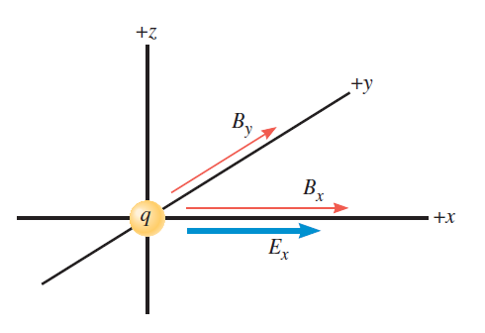

- The drawing shows a wire of length l (a = 30cm, b = 40 cm) with a current I = 10 A lying in x-y plane. There is also a homogeneous magnetic field $\vec{B}$ = 0.5·$\vec{j}$ + 0.2·$\vec{k}$. (T) Find the components F_{x}, F_{y} and F_{z} of the force that acts on the wire. -10-
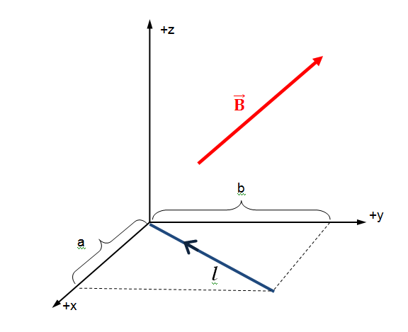

- A constant magnetic field passes through a single rectangular loop whose dimensions are 0.3m×0.5m. The magnetic field has a magnitude of 2 T and is perpendicular to the plane of the loop. +

- If the magnetic field decreases to zero in a time of 0.5 s, what is the magnitude of the average EMF induced in the loop? -5-

- If the magnetic field remains constant at its initial value of 2 T, what is the magnitude of the rate at which the area should change so that the average EMF has the same magnitude as in part (a)? -5-

- The equation of the change with time of the current in a circuit is given as i= – 0.2·sin(400·π·t) (amper). The Inductance of the circuit is L=1 H.
Find:
- the period of oscillations; -5-

- the maximum energy of the electric field. -5-

9. A series RLC circuit has a resistance of R=80 Ω and an impedance of Z=100 Ω. +

a) What average power P is delivered to this circuit when U_{rms} = 200 V?
-5-

b) Find the tangent of the phase angle tanφ. -5-

- When the light ray illustrated in figure passes through the glass block of index of refraction n=1.5, it is shifted laterally by the distance d (H=2cm, θ=30°, light speed in vacuum is c=3·10⁸ m/s). The solution can be represented in symbols, getting the final solution expressed in given values.

a) Find the value of d. -5-

b) Find the time interval required for the light to pass through the glass block. -5-
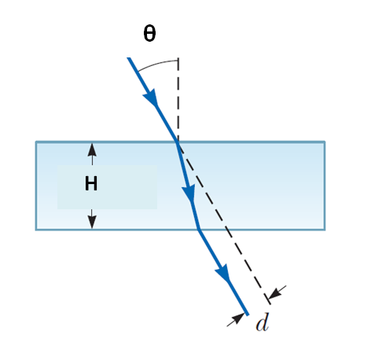

1. A nichrome wire with a 1 mm cross-sectional radius is to be used in winding a heating coil. If 120 C of charge passes through the coil in 1 minute when a voltage of 120 V is applied across its ends (resistivity of the nichrome is ρ=1.2×10⁻⁶ Ω·m, π =3). Find the
a) required resistance of the coil 5.
A | B | C | D | E
50 Ω | 55 Ω | 65 Ω | 60 Ω | 70 Ω
b) length of wire you must use to make the coil. 5
A | B | C | D | E
150 m | 140 m | 155 m | 145 m | 158 m

2. A certain waffle iron is rated at 1.1 kW (kilowatt) when connected to a 220-V source.

- What current does the waffle iron carry? 5

A | B | C | D | E
3 A | 5 A | 4 A | 6 A | 2 A

b) What is its resistance? 5

A | B | C | D | E
52 Ω | 55 Ω | 44 Ω | 60 Ω | 34 Ω

3. Resistors R₁ = 3 Ω, R₂ = 4 Ω, R₃ = 6 Ω and R₄ = 1.6 Ω are connected in circuit as drawn shows…
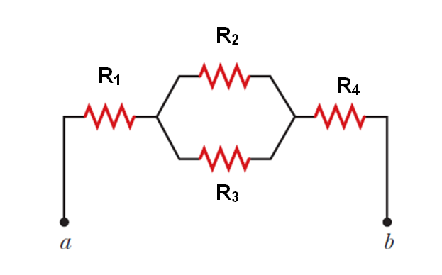
- Find the equivalent resistance between points a and b in figure. 5

A | B | C | D | E
5.2 Ω | 8 Ω | 4 Ω | 6 Ω | 7 Ω

- Calculate the current in each resistor if a potential difference of 35 V is applied between points a and b. 5.

A | B | C | D | E
i₁=5A i₂=3A i₃=2A i₄=5A | i₁=5A i₂=5A i₃=5A i₄=5A | i₁=3A i₂=5A i₃=5A i₄=2A | i₁=2A i₂=3A i₃=2A i₄=3A | i₁=3A i₂=3A i₃=2A i₄=2A

4. An uncharged capacitor and a resistor are connected in series to a source of emf. If ξ = 9 V, C = 20 μF, and R = 100 Ω, (Euler's number e can be taken to equal 2.5.) find:

- the time constant Ƭ of the circuit; 5

A | B | C | D | E
3 ms | 2 ms | 1 ms | 4 ms | 2.8 ms

- the maximum charge on the capacitor; 5

A | B | C | D | E
160 μC | 175 μC | 180 μC | 185 μC | 190 μC

- the charge on the capacitor at a time equal to one time constant after the battery is connected. 5
A | B | C | D | E
106 μC | 105 μC | 100 μC | 108 μC | 109 μC

5. A 1μC point charge moves with a velocity of $\vec{v}$=(50$\vec{i}$ +20$\vec{j}$) m/s in a region in which the magnetic field is $\vec{B}$ = 0.2$\vec{k}$ T. What is the magnitude of the magnetic force this particle experiences? 5

A | B | C | D | E
$\sqrt{101}$μN | 14 μN | 6 μN | $\sqrt{96}$ μN | $\sqrt{116}$ μN

6. The drawing shows a wire ab on the y-z plane with a I=2A current. Points a and b have coordinates (0, 4, 0)m and (0, 0, 5)m respectively. There is also a magnetic field B = 0.5 T that is the same everywhere and points in the direction of the +x axis. Find the components Fx, Fy and Fz of the force that acts on the wire. 5.
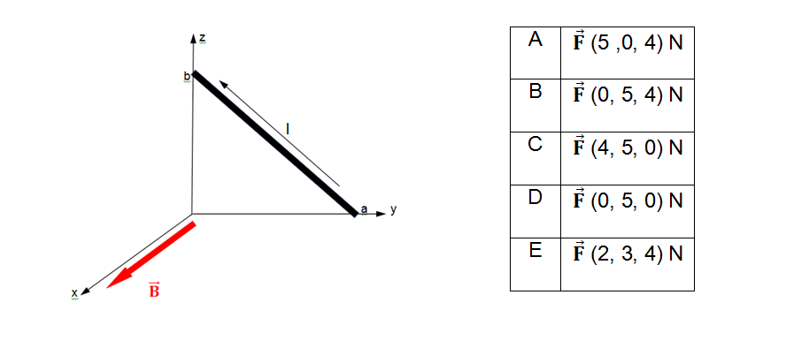

7. Two long, parallel wires carry currents of I₁ = 3 A and I₂ = 5 A in the directions indicated in figure. Find the magnitude and direction of the magnetic field at a point midway between the wires (d=2cm). 5
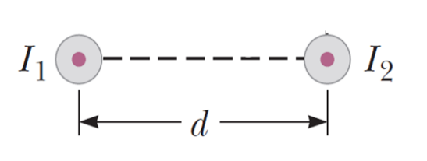
A | B | C | D | E
25 μT  upward | 30 μT  upward | 40 μT downward | zero | 25 μT downward

8. A cube of edge length a = 2 cm is positioned as shown in figure. A uniform magnetic field given by $\vec{B}$= (4$\vec{i}$ + 3$\vec{j}$ + 5$\vec{k}$) T exists throughout the region. Calculate the magnetic flux through the shaded face. 5
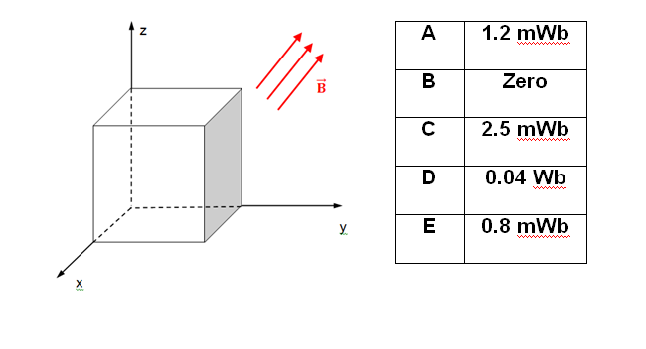

9. A 2 m length of wire is held in an east–west direction and moves horizontally to the north with a speed of 0.5 m/s. The Earth’s magnetic field in this region is of magnitude 50 mT and is directed northward and θ=55º below the horizontal. Calculate the magnitude of the induced EMF between the ends of the wire. 5.
A | 28. 68 mV
B | 35.00 mV
C | 48.32 mV
D | 40.96 mV
E | zero

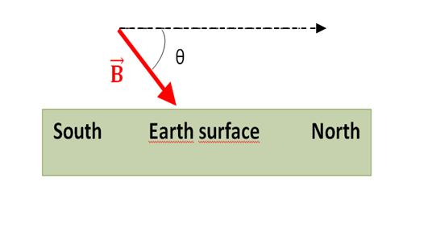

10. Consider the arrangement shown in figure. Assume that R = 8 Ω, L = 1.6 m, and a uniform 2.5 T magnetic field is directed into the page. At what speed $\vec{V}$ (in m/s) should the bar be moved to produce a current of 0.5 A in the resistor? 5
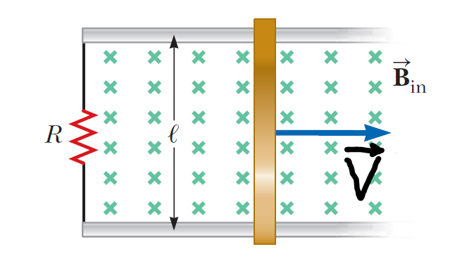
A | B | C | D | E
2 m/s | 1 m/s | 0.5 m/s | 0.2 m/s | 1.5 m/s

11. The magnetic flux through a metal ring varies with time t according to Φ_{B}=at³–bt² (Wb), where a = 6 Wb·s^{–3}, b = 18 Wb·s^{–2}, and t is in seconds. The resistance of the ring is 3 Ω.
Determine:

- EMF at t = 0.5 s; 5

A | B | C | D | E
zero | 5.5 V | 2 V | 13.5 V | 15 V

- the current at t = 0.5 s; 5

- the maximum current induced in the ring. 5

9. In figure R₁ = 10 Ω, R₂ = 20 Ω, R₃ = 30 Ω, ξ₁ = 20 V and ξ₂ = 30 V.
Find:
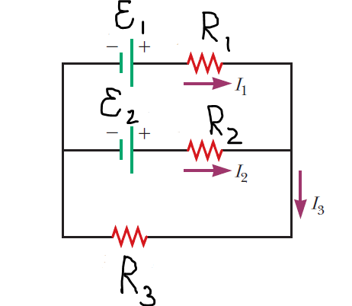
a) the current in each resistor, 5
b) the power delivered to each resistor. 5

Bonus problem (20 points)

The circuit in figure is located in a magnetic field whose magnitude varies with time according to the expression B=10^{–3}·t, where B is in teslas and t is in seconds. Assume the resistance per length of the wire is 0.1 Ω/m. Find the current in section PQ of length a=50 cm.

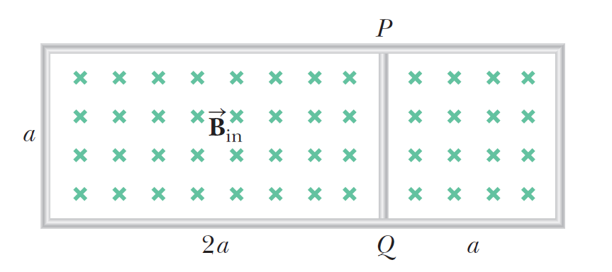
- Charges +2q and −q are placed at (a, 0) and (−a, 0) respectively as shown in the figure. The coordinates of the point at which electric field intensity is zero will be (x, 0), where 5

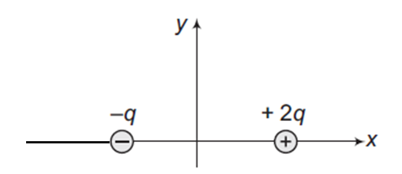

A | B | C | D | E
x < − a | x > − a | 0 < x < a | −a < x < a | x > a

- Two point charges q₁ and q₂ are placed at a distance of 50 cm from each other in air, and interact with a certain force. The same charges are now put in oil whose relative permittivity is ε=4. If the interacting force between them is still the same, their separation now is
5
A | B | C | D | E
16.6 cm | 22.3 cm | 28.4 cm | 25.0 cm | 20.4 cm

- Two identical small conducting spheres having unequal positive charges q₁ and q₂ are separated by a distance r. If they are now made to touch each other and then separated again to the same distance, the electrostatic force between them in this case will be
5
A | B | C | D | E
less than before | same as before | more than before | zero | will diminish twofold

- The electric field in a region of space is given by $\vec{E}$= 5$\vec{i}$ + 2$\vec{j}$ N/C. The flux of $\vec{E}$ due to this field through an area 1 m² lying in the y-z plane, in V·m units, is 5
A | B | C | D | E
5 | 10 | 2 | 29 | $\sqrt{7}$

- The linear charge density of uniformly charged filament is λ=5.28·10^{–8}C/m. Calculate the magnitude of the electric field intensity at a distance of 10 cm from the filament (π=3, ε_{o}=8.8·10^{–12} C²/N·m²). 5
A | B | C | D | E
11 kN/C | 13 kN/C | 9 kN/C | 10 kN/C | 8 kN/C

- A uniform electric field of magnitude 1.25·10⁴ V/m is perpendicular to a square sheet with sides 2 m long. What is the electric flux through the sheet? 5

A | B | C | D | E
5·10⁴ V·m | 2.5·10⁴ V·m | 1.25·10⁴ V·m | 10⁴ V·m | 6.5·10⁴ V·m

- Calculate the flux through the sheet of the previous problem (ques.6) if the plane of the sheet is at an angle of 30° to the field. Find the flux for both directions of the unit normal to the sheet. 5

A | B | C | D | E
5·10⁴ V·m | 2.5·10⁴ V·m | 1.25·10⁴ V·m | 0.5·10⁴ V·m | 13·10⁴ V·m

- A charge Q is located inside a rectangular box. The electric flux through each of the six surfaces of the box is: Φ₁=+1400V·m, Φ₂=+2500V·m, Φ₃=+4600V·m, Φ₄= –1800V·m, Φ₅= –3500V·m, and Φ₆= –5200V·m. What is Q? (ε_{o}=8·10^{–12} C²/N·m²) 5

A | B | C | D | E
- 14 nC | 18 nC | - 16 nC | 15 nC | - 19 nC

- What is the total electric potential at point A, as shown in figure? 5
A | $$\frac{k·q}{d}$$
B | zero
C | $$\frac{k·2q}{d}$$
D | $$\frac{k·2q}{d\sqrt{2}}$$
E | $$\frac{k·q}{d\sqrt{2}}$$

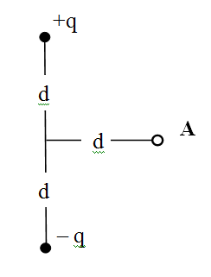

- At a certain distance from a point charge, the field intensity is 500V/m and the potential is 3000V.

- The distance to the charge is… 5
A | B | C | D | E
7 m | 2 m | 5 m | 6 m | 4 m

- The magnitude of the charge is…5
A | B | C | D | E
6 μC | 2 μC | 4 μC | 3 μC | 5 μC

- When a potential difference of 150 V is applied to the plates of a parallel-plate capacitor, the plates carry a surface charge density of 3·10^{–6}C/m². What is the spacing between the plates? (ε_{o}=8·10^{–12} C²/N·m²). 5
A | B | C | D | E
0.2 mm | 0.6 mm | 0.4 mm | 0.3 mm | 0.5 mm

- Two capacitors, C₁ = 4 μF and C₂ = 6 μF, are connected in parallel, and the resulting combination is connected to a 10 V battery. Find:
- the equivalent capacitance of the combination 5
A | B | C | D | E
5 μF | 12 μF | 10 μF | 8 μF | 2.4 μF

- the potential difference across each capacitor 5
A | B | C | D | E
10V, 10V | 8V, 12V | 40V, 60V | 0.4V, 0.6V | 20V, 20V

- the charge stored on each capacitor 5
A | B | C | D | E
4μC, 6μC | 40μC, 60μC | 10μC, 10μC | 80μC, 120μC | 20μC, 20μC

- A sphere with a radius of 1 m is charged to a potential of 30 000 V. Find the energy of the charged ball (π=3, ε_{o}=8·10^{–12} C²/N·m²). 5
A | B | C | D | E
215·10^{–4} J | 601·10^{–4} J | 511·10^{–4} J | 432·10^{–4} J | 322·10^{–4} J

- A parallel-plate capacitor with a plate separation d has a capacitance C_{o} in the absence of a dielectric. What is the capacitance when a slab of dielectric material of dielectric constant ε and thickness f·d is inserted between the plates, where f is a fraction between 0 and 1 (i.e. 0 $<$ f $<$ 1)? 5
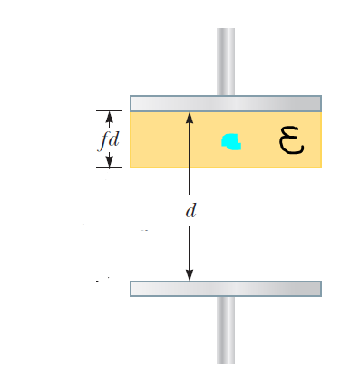
- What work is performed when a point charge of 2·10^{–8}C is transferred from infinity to a point at a distance of 1 cm from the surface of a ball with a radius of 1 cm and a charge surface density of σ=10^{–4} C/m² (π=3, ε_{o}=8·10^{–12} C²/N·m²)? 5

- A closed surface with dimensions a=b=0.5 m and c=0.8 m is located as shown in figure. The left edge of the closed surface is located at position x=a. The electric field throughout the region is non-uniform and is given by $\vec{E}$ = (5 + 4x²)·$\vec{i}$ N/C, where x is in meters.

a) Calculate the net electric flux leaving the closed surface; 5
b) What net charge is enclosed by the surface? 5

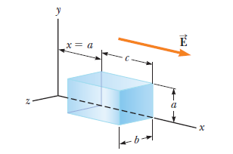

1. A nichrome wire with a 1 mm cross-sectional radius is to be used in winding a heating coil. If 120 C of charge passes through the coil in 1 minute when a voltage of 120 V is applied across its ends (resistivity of the nichrome is ρ=1.2×10⁻⁶ Ω·m, π =3). Find the
a) required resistance of the coil 5..
A | B | C | D | E
50 Ω | 55 Ω | 60 Ω | 65 Ω | 70 Ω
b) length of wire you must use to make the coil. 5
A | B | C | D | E
155 m | 140 m | 150 m | 145 m | 158 m

2. A certain waffle iron is rated at 1.1 kW (kilowatt) when connected to a 220-V source.

- What current does the waffle iron carry? 5

A | B | C | D | E
3 A | 2 A | 4 A | 6 A | 5 A

b) What is its resistance? 5

A | B | C | D | E
44 Ω | 55 Ω | 41 Ω | 60 Ω | 34 Ω

3. Resistors R₁ = 3 Ω, R₂ = 4 Ω, R₃ = 6 Ω and R₄ = 1.6 Ω are connected in circuit as drawn shows…

- Find the equivalent resistance between points a and b in figure. 5

A | B | C | D | E
5 Ω | 8 Ω | 4.2 Ω | 7 Ω | 6 Ω

- Calculate the current in each resistor if a potential difference of 35 V is applied between points a and b. 5..

A | B | C | D | E
i₁=5A i₂=5A i₃=5A i₄=5A | i₁=5A i₂=3A i₃=2A i₄=5A | i₁=3A i₂=5A i₃=5A i₄=2A | i₁=2A i₂=3A i₃=2A i₄=3A | i₁=3A i₂=3A i₃=2A i₄=2A

4. An uncharged capacitor and a resistor are connected in series to a source of emf. If ξ = 9 V, C = 20 μF, and R = 100 Ω, (Euler's number e can be taken to equal 2.5.) find:

- the time constant Ƭ of the circuit; 5

A | B | C | D | E
2 ms | 3 ms | 1 ms | 4 ms | 2.8 ms

- the maximum charge on the capacitor; 5

A | B | C | D | E
160 μC | 175 μC | 185 μC | 180 μC | 190 μC

- the charge on the capacitor at a time equal to one time constant after the battery is connected. 5
A | B | C | D | E
106 μC | 108 μC | 100 μC | 105 μC | 109 μC

5. A 1μC point charge moves with a velocity of $\vec{v}$=(50$\vec{i}$ +20$\vec{j}$) m/s in a region in which the magnetic field is $\vec{B}$ = 0.2$\vec{k}$ T. What is the magnitude of the magnetic force this particle experiences? 5

A | B | C | D | E
$\sqrt{101}$μN | 14 μN | $\sqrt{116}$ μN | $\sqrt{96}$ μN | zero

6. The drawing shows a wire ab on the y-z plane with a I=4A current. Points a and b have coordinates (0, 4, 0)m and (0, 0, 5)m respectively. There is also a magnetic field B = 0.25 T that is the same everywhere and points in the direction of the +x axis. Find the components Fx, Fy and Fz of the force that acts on the wire. 5..


7. Two long, parallel wires carry currents of I₁ = 0.2 A and I₂ = 0.4 A in the directions indicated in figure. Find the magnitude and direction of the magnetic field at a point midway between the wires (d=2cm). 5

A | B | C | D | E
25 μT  upward | 30 μT  upward | 2.5 μT downward | zero | 4 μT downward

8. A cube of edge length a = 1 cm is positioned as shown in figure. A uniform magnetic field given by $\vec{B}$= (4$\vec{i}$ + 12$\vec{j}$ + 15$\vec{k}$) T exists throughout the region. Calculate the magnetic flux through the shaded face. 5


9. A 2 m length of wire is held in an east–west direction and moves horizontally to the north with a speed of 0.25 m/s. The Earth’s magnetic field in this region is of magnitude 100 mT and is directed northward and θ=55º below the horizontal. Calculate the magnitude of the induced EMF between the ends of the wire. 5..
A | 28. 68 mV
B | 35.00 mV
C | 48.32 mV
D | 40.96 mV
E | zero



10. Consider the arrangement shown in figure. Assume that R = 4 Ω, L = 1.6 m, and a uniform 2.5 T magnetic field is directed into the page. At what speed $\vec{V}$ (in m/s) should the bar be moved to produce a current of 0.5 A in the resistor? 5

A | B | C | D | E
2 m/s | 1 m/s | 0.5 m/s | 0.2 m/s | 1.5 m/s

11. The magnetic flux through a metal ring varies with time t according to Φ_{B}=at³–bt² (Wb), where a = 6 Wb·s^{–3}, b = 18 Wb·s^{–2}, and t is in seconds. The resistance of the ring is 3 Ω.
Determine:

- EMF at t = 0.5 s; 5

A | B | C | D | E
zero | 13.5 V | 2 V | 5.5 V | 15 V

- the current at t = 0.5 s; 5

- the maximum current induced in the ring. 5

9. In figure R₁ = 10 Ω, R₂ = 20 Ω, R₃ = 30 Ω, ξ₁ = 20 V and ξ₂ = 30 V..
Find:

a) the current in each resistor, 5
b) the power delivered to each resistor. 5

Bonus problem (20 points)

The circuit in figure is located in a magnetic field whose magnitude varies with time according to the expression B=10^{–3}·t, where B is in teslas and t is in seconds. Assume the resistance per length of the wire is 0.1 Ω/m. Find the current in section PQ of length a=50 cm.



- A small plastic ball of mass m is suspended by a long string in a uniform electric field $\vec{E}$ as shown in figure. If the ball is in equilibrium when the string makes a φ angle with the vertical, express…×

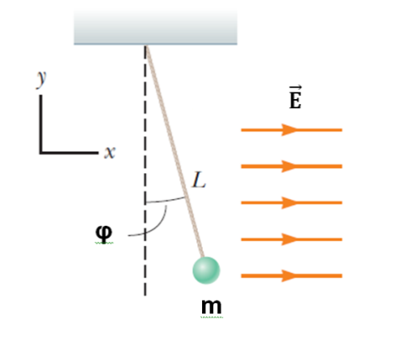
- the net charge on the ball? -5-

- the tension in the thread? -5-

in terms m, E, and φ.

- The drawing shows an edge-on view of two planar surfaces that intersect and are mutually perpendicular. Surface 1 has an area of A₁ = 1 m², while surface 2 has an area of A₂ = 2 m². The electric field in the drawing is uniform and has a magnitude of E=200 N/C (θ=60°). Find the magnitude of the electric flux through



a) surface 1 -5-

b) surface 2 -5-

3. A sphere with a radius of 0.5 m is charged to a potential of 20000 V (π=3, ε_{o}=8·10^{–12} C²/N·m²). Find the: ×

- energy of the charged ball W -5-

- surface charge density σ. -5-

- Consider the circuit shown in figure where R₁ = 10 Ω, R₂ = 5 Ω, R₃ = 10 Ω, R₄ = 3 Ω, R₅ = 2 Ω, and ε = 36 V Find:
a) the current in the R₅ resistor; -5-

b) the potential difference between points -5-
a and b.



- A particle has a charge of +1 mC and is located at the coordinate origin. As the drawing shows, an electric field of E_{x} = 100 V/m exists along the +x axis. A magnetic field also exists, and its components are B_{x} = 1 T and B_{y} = 1.5 T. Calculate the magnitude of the force exerted on the particle by each of the three fields when it is: ×
- stationary, -5-
- moving along the “– z” axis at a speed of 500 m/s. -5-


- The drawing shows a wire of length l (a = 20cm, b = 30 cm) with a current I = 10 A lying in x-y plane. There is also a homogeneous magnetic field $\vec{B}$ = 0.2·$\vec{j}$ + 0.5·$\vec{k}$ (T). Find the components F_{x}, F_{y} and F_{z} of the force that acts on the wire. -10-


- A constant magnetic field passes through a single rectangular loop whose dimensions are 0.2m×0.5m. The magnetic field has a magnitude of 2.5 T and is perpendicular to the plane of the loop. ×

- If the magnetic field decreases to zero in a time of 0.25 s, what is the magnitude of the average EMF induced in the loop? -5-

- If the magnetic field remains constant at its initial value of 2.5 T, what is the magnitude of the rate at which the area should change so that the average EMF has the same magnitude as in part (a)? -5-

- The equation of the change with time of the current in a circuit is given as i= – 0.4·sin(200·π·t) (amper). The Inductance of the circuit is L = 2 H.
Find:
- the period of oscillations; -5-

- the maximum energy of the electric field. -5-

9. A series RLC circuit has a resistance of R=100 Ω and an impedance of Z=150 Ω. ×

a) What average power is delivered to this circuit when U_{rms} = 300 V?
-5-

b) Find the tangent of the phase angle tanφ. -5-

- When the light ray illustrated in figure passes through the glass block of index of refraction n=1.2, it is shifted laterally by the distance d (H=20mm, θ=40°, light speed in vacuum is c=3·10⁸ m/s). The solution can be represented in symbols, getting the final solution expressed in given values.

a) Find the value of d. -5-

b) Find the time interval required for the light to pass through the glass block. -5-


- Charges +2q and −q are placed at (a, 0) and (−a, 0) respectively as shown in the figure. The coordinates of the point at which electric field intensity is zero will be (x, 0), where 5



A | B | C | D | E
x > − a | x < − a | −a < x < a | 0 < x < a | x > a

- Two point charges q₁ and q₂ are placed at a distance of 45 cm from each other in air, and interact with a certain force. The same charges are now put in oil whose relative permittivity is ε=4. If the interacting force between them is still the same, their separation now is
5
A | B | C | D | E
16.6 cm | 22.5 cm | 28.4 cm | 25.0 cm | 20.4 cm

- Two identical small conducting spheres having unequal negative charges q₁ and q₂ are separated by a distance r. If they are now made to touch each other and then separated again to the same distance, the electrostatic force between them in this case will be
5
A | B | C | D | E
less than before | zero | will diminish twofold | same as before | more than before

- The electric field in a region of space is given by $\vec{E}$= 5$\vec{i}$ + 4$\vec{j}$ N/C. The flux of $\vec{E}$ due to this field through an area 0.5 m² lying in the x-z plane, in V·m units, is 5
A | B | C | D | E
4 | 11 | 29 | 2 | $\sqrt{7}$

..
- The linear charge density of uniformly charged filament is λ=5.28·10^{–8}C/m. Calculate the magnitude of the electric field intensity at a distance of 20 cm from the filament (π=3, ε_{o}=8.8·10^{–12} C²/N·m²). 5
A | B | C | D | E
5 kN/C | 3 kN/C | 9 kN/C | 10 kN/C | 8 kN/C

- A uniform electric field of magnitude 1.2·10⁴ V/m is perpendicular to a square sheet with sides 1 m long. What is the electric flux through the sheet? 5

A | B | C | D | E
5·10⁴ V·m | 2.5·10⁴ V·m | 1.2·10⁴ V·m | 10⁴ V·m | 6.5·10⁴ V·m

- Calculate the flux through the sheet of the previous problem (ques.6) if the plane of the sheet is at an angle of 30° to the field. Find the flux for both directions of the unit normal to the sheet. 5

A | B | C | D | E
5·10⁴ V·m | 2.5·10⁴ V·m | 1.2·10⁴ V·m | 0.6·10⁴ V·m | 12·10⁴ V·m

- A charge Q is located inside a rectangular box. The electric flux through each of the six surfaces of the box is: Φ₁=+2400V·m, Φ₂=+3000V·m, Φ₃=+4600V·m, Φ₄= –1800V·m, Φ₅= –2500V·m, and Φ₆= –5200V·m. What is Q? (ε_{o}=8·10^{–12} C²/N·m²) 5

A | B | C | D | E
- 4 nC | 4 nC | - 6 nC | 15 nC | 2 nC

..

- What is the total electric potential at point A, as shown in figure? 5
A | $$\frac{k·q}{d}$$
B | $$\frac{k·q}{d\sqrt{2}}$$
C | $$\frac{k·2q}{d}$$
D | $$\frac{k·2q}{d\sqrt{2}}$$
E | zero

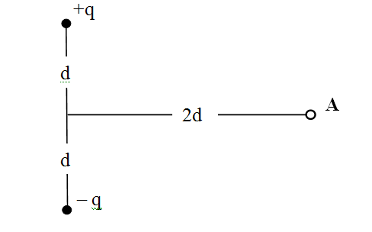

- At a certain distance from a point charge, the field intensity is 100V/m and the potential is 300V.

- The distance to the charge is… 5
A | B | C | D | E
7 m | 2 m | 3 m | 6 m | 2 m

- The magnitude of the charge is…5
A | B | C | D | E
0.1 μC | 0.2 μC | 0.4 μC | 0.03 μC | 0.5 μC

- When a potential difference of 300 V is applied to the plates of a parallel-plate capacitor, the plates carry a surface charge density of 3·10^{–6}C/m². What is the spacing between the plates? (ε_{o}=8·10^{–12} C²/N·m²). 5
A | B | C | D | E
0.2 mm | 0.6 mm | 0.9 mm | 0.8 mm | 0.5 mm

..
- Two capacitors, C₁ = 4 μF and C₂ = 8 μF, are connected in parallel, and the resulting combination is connected to a 100 V battery. Find:
- the equivalent capacitance of the combination 5
A | B | C | D | E
5 μF | 12 μF | 10 μF | 8 μF | 2.4 μF

- the potential difference across each capacitor 5
A | B | C | D | E
10V, 15V | 50V, 50V | 40V, 60V | 100V, 100V | 20V, 20V

- the charge stored on each capacitor 5
A | B | C | D | E
0.4mC, 0.8mC | 0.4mC,  0.6mC | 100μC,  100μC | 80μC,  120μC | 200μC,  200μC

- A sphere with a radius of 0.5 m is charged to a potential of 30 000 V. Find the energy of the charged ball (π=3, ε_{o}=8·10^{–12} C²/N·m²). 5
A | B | C | D | E
216·10^{–4} J | 600·10^{–4} J | 512·10^{–4} J | 432·10^{–4} J | 320·10^{–4} J

- A parallel-plate capacitor with a plate separation d has a capacitance C_{o} in the absence of a dielectric. What is the capacitance when a slab of dielectric material of dielectric constant ε and thickness f·d is inserted between the plates, where f is a fraction between 0 and 1 (i.e. 0 $<$ f $<$ 1)? 5
.. 
- What work is performed when a point charge of 4·10^{–8}C is transferred from infinity to a point at a distance of 2 cm from the surface of a ball with a radius of 2 cm and a charge surface density of σ=2·10^{–4} C/m² (π=3, ε_{o}=8·10^{–12} C²/N·m²)? 5

- A closed surface with dimensions a=b=0.5 m and c = 1 m is located as shown in figure. The left edge of the closed surface is located at position x=a. The electric field throughout the region is non-uniform and is given by $\vec{E}$ = (2 + 8x²)·$\vec{i}$ N/C, where x is in meters.

a) Calculate the net electric flux leaving the closed surface; 5
b) What net charge is enclosed by the surface? 5


- An emf of 40 mV is induced in a 200-turn coil when the current is changing at the rate of 20 A/s. +

- Find the inductance of the coil. 5

A | B | C | D | E
2 mH | 2.5 mH | 3 mH | 3.5 mH | 4.5 mH

- What is the magnetic flux through each turn of the coil at an instant when the current is 5 A? 5

A | B | C | D | E
45 μWb | 95 μWb | 75 μWb | 50 μWb | 30 μWb

- In the circuit shown in figure, let L = 4 H, R = 20 Ω, and ξ = 100 V.

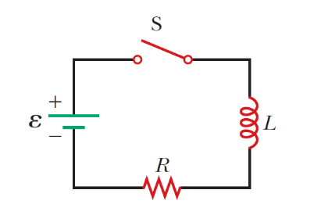

- What is the time constant of the circuit Ƭ? 5

A | B | C | D | E
5 s | 0.5 s | 2.2 s | 0.2 s | 0.4 s

- What is the self-induced EMF after a time interval equal to one time constant the switch is closed (switching on)? e=2.5 5

A | B | C | D | E
72 V | 26 V | 60 V | 52 V | 40 V

- What is the value of the final steady-state current I_{max}? 5

A | B | C | D | E
5 A | 2 A | 9 A | 7 A | 3 A

- The switch in figure is connected to position a for a long time interval. At t=0, the switch is thrown to position b. (C=20 μF, L=0.2 H, ξ=15 V) After this time, what are… +



a) the cyclic frequency ω of oscillation of the LC circuit (in rad/s)? 5

A | B | C | D | E
980 | 850 | 500 | 290 | 1000

b) the maximum charge that appears on the capacitor? 5

A | B | C | D | E
110 μC | 120 μC | 100 μC | 90 μC | 300 μC

c) the maximum current in the inductor? 5

A | B | C | D | E
0.15 A | 0.1 A | 0.9 A | 1.2 A | 1.3 A

- Two capacitors with capacitances of C₁ = 4 μF and C₂ = 6 μF are connected in series to an alternating current circuit with a voltage of 100 V and a frequency of 50 Hz (π=3). Find:

a) the intensity of the current in the circuit, 5
A | B | C | D | E
52 mA | 62 mA | 82 mA | 72 mA | 50 mA

b) the potential drop across the first and second capacitors. 5
A | B | C | D | E
U₁=12V  U₂=8V | U₁=60V  U₂=40V | U₁=40V  U₂=60V | U₁=80V  U₂=10V | U₁=10V  U₂=9V

- The voltage phasor diagram for a certain series RLC circuit is shown in figure. The resistance of the circuit is R=20 Ω, and the frequency is f=50 Hz (U_{L}= 9 V, U_{R} = 8 V, U_{C} = 3 V). Find: +


- the maximum voltage U_{max}, 5

A | B | C | D | E
10 V | 15 V | 11 V | 5 V | 6 V

- the maximum current I_{max}, 5

A | B | C | D | E
2 A | 0.4 A | 2.5 A | 0.1 A | 1.5 A

- the impedance Z, 5

A | B | C | D | E
27 Ω | 23 Ω | 35 Ω | 20 Ω | 25 Ω

- the capacitance C 5
__________________

- the inductance of the circuit L 5
__________________

- A beam of light both reflects and refracts at the surface between air (n_{air}=1) and glass as shown in figure. An incidence angle is θ, and the reflected and the refracted ray perpendicular to each other (c – light speed in vacuum). Find +

- the refractive index of the glass n 5
A | B | C | D | E
sinθ | tanθ | cosθ | cotθ | tan^{–1} θ

- light speed in the given glass v 5
A | B | C | D | E
c·cosθ | c·sinθ | c·cotθ | c·tan²θ | c/cosθ

- An object is placed d_{o}=60 cm from a concave spherical mirror with focal length of magnitude f=30 cm.

a) Find the location of the image. 5
b) What is the magnification of the image? 5
c) What is the radius of curvature of the mirror? 5

A | B | C | D | E
30 cm | 50 cm | 60 cm | 15 cm | 40 cm

- A small spherical insulator of mass m and charge q is hung by a thread of negligible mass. A charge of q′ is held d away from the sphere and directly to the right of it, so the thread makes an angle θ with the vertical (see the drawing). Express: #
a) the angle θ -5-
b) the tension T -5-

in terms m, q, q′ and d.



- The drawing shows an edge-on view of two planar surfaces that intersect and are mutually perpendicular. Surface 1 has an area of A₁ = 2 m², while surface 2 has an area of A₂ = 4 m². The electric field in the drawing is uniform and has a magnitude of E=100 N/C (θ=30°). Find the magnitude of the electric flux through



a) surface 1 -5-

b) surface 2 -5-
3. A sphere with a radius of 0.25 m is charged to a potential of 40000 V (π=3, ε_{o}=8·10^{–12} C²/N·m²). Find the: #

- energy of the charged ball W -5-

- surface charge density σ. -5-

- Consider the circuit shown in figure where R₁ = 100 Ω, R₂ = 50 Ω, R₃ = 100 Ω, R₄ = 30 Ω, R₅ = 20 Ω, and ε = 480 V Find:
a) the current in the R₅ resistor; -5-

b) the potential difference between points -5-
a and b.



- A particle has a charge of +1 mC and is located at the coordinate origin. As the drawing shows, an electric field of E_{x} = 300 V/m exists along the +x axis. A magnetic field also exists, and its components are B_{x}=1 T and B_{y} = 2 T. Calculate the magnitude of the force exerted on the particle by each of the three fields when it is: #
- stationary, -5-
- moving along the “– z” axis at a speed of 100 m/s. -5-


- The drawing shows a wire of length l (a = 10cm, b = 20 cm) with a current I = 1 A lying in x-y plane. There is also a homogeneous magnetic field $\vec{B}$ = 5·$\vec{j}$ + 2·$\vec{k}$. (T) Find the components F_{x}, F_{y} and F_{z} of the force that acts on the wire. -10-


- A constant magnetic field passes through a single rectangular loop whose dimensions are 0.2m×0.8m. The magnetic field has a magnitude of 0.5 T and is perpendicular to the plane of the loop. #

- If the magnetic field decreases to zero in a time of 0.25 s, what is the magnitude of the average EMF induced in the loop? -5-

- If the magnetic field remains constant at its initial value of 0.5 T, what is the magnitude of the rate at which the area should change so that the average EMF has the same magnitude as in part (a)? -5-

- The equation of the change with time of the current in a circuit is given as i= – 0.8·sin(100·π·t) (amper). The Inductance of the circuit is L=1 H.
Find:
- the period of oscillations; -5-

- the maximum energy of the electric field. -5-

9. A series RLC circuit has a resistance of R=50 Ω and an impedance of Z=100 Ω. #

a) What average power P is delivered to this circuit when U_{rms} = 300 V?
-5-

b) Find the tangent of the phase angle tanφ. -5-

- When the light ray illustrated in figure passes through the glass block of index of refraction n=1.3, it is shifted laterally by the distance d (H=2cm, θ=50°, light speed in vacuum is c=3·10⁸ m/s). The solution can be represented in symbols, getting the final solution expressed in given values.

a) Find the value of d. -5-

b) Find the time interval required for the light to pass through the glass block. -5-



- An emf of 50 mV is induced in a 400-turn coil when the current is changing at the rate of 5 A/s. *

- Find the inductance of the coil. 5
A | B | C | D | E
11.2 mH | 5.5 mH | 8 mH | 12 mH | 10 mH

- What is the magnetic flux through each turn of the coil at an instant when the current is 2 A? 5
A | B | C | D | E
45 μWb | 90 μWb | 50 μWb | 75 μWb | 40 μWb

- In the circuit shown in figure, let L = 8 H, R = 50 Ω, and ξ = 200 V.

- What is the time constant of the circuit Ƭ? 5

A | B | C | D | E
0.16 s | 0.5 s | 2 s | 0.2 s | 1.4 s

- What is the self-induced EMF after a time interval equal to one time constant the switch is closed (switching on)? e=2.5 5

A | B | C | D | E
70 V | 80 V | 120 V | 52 V | 140 V

- What is the value of the final steady-state current I_{max}? 5

A | B | C | D | E
5 A | 2 A | 4 A | 7 A | 3 A

- The switch in figure is connected to position a for a long time interval. At t=0, the switch is thrown to position b. (C=10 μF, L=0.4 H, ξ=2.5 V) After this time, what are… *



a) the cyclic frequency ω of oscillation of the LC circuit (in rad/s)? 5

A | B | C | D | E
980 | 500 | 850 | 250 | 750

b) the maximum charge that appears on the capacitor? 5

A | B | C | D | E
25 μC | 12 μC | 10 μC | 45 μC | 30 μC

c) the maximum current in the inductor? 5

A | B | C | D | E
15.4mA | 1 mA | 9 mA | 12.5mA | 13 mA

- Two capacitors with capacitances of C₁ = 3 μF and C₂ = 2 μF are connected in series to an alternating current circuit with a voltage of 100 V and a frequency of 50 Hz (π=3). Find:

a) the intensity of the current in the circuit, 5
A | B | C | D | E
52 mA | 62 mA | 72 mA | 82 mA | 36 mA

b) the potential drop across the first and second capacitors. 5
A | B | C | D | E
U₁=120V  U₂=80V | U₁=80V  U₂=120V | U₁=100V  U₂=80V | U₁=60V  U₂=40V | U₁=40V  U₂=60V

- The voltage phasor diagram for a certain series RLC circuit is shown in figure. The resistance of the circuit is R = 15 Ω, and the frequency is f=50 Hz (U_{L}= 120 V, U_{R} = 60 V, U_{C} = 40 V). Find: *


- the maximum voltage U_{max}, 5

A | B | C | D | E
120 V | 60 V | 100 V | 80 V | 50 V

- the maximum current I_{max}, 5

A | B | C | D | E
2.8 A | 0.4 A | 2.5 A | 4 A | 1.5 A

- the impedance Z, 5

A | B | C | D | E
25 Ω | 23 Ω | 35 Ω | 20 Ω | 21 Ω

- the capacitance C, 5
__________________

- the inductance of the circuit L 5
__________________

- A beam of light both reflects and refracts at the surface between air (n_{air}=1) and glass as shown in figure. An incidence angle is θ, and the reflected and the refracted ray perpendicular to each other (c – light speed in vacuum). Find *

- the refractive index of the glass n 5
A | B | C | D | E
sinθ | Cosθ | tan^{–1}θ | cotθ | tanθ
- light speed in the given glass v 5
A | B | C | D | E
c·tan²θ | c·sinθ | c·cosθ | c·cotθ | c/cosθ

- An object is placed d_{o}=40 cm from a concave spherical mirror with focal length of magnitude f=10 cm.


a) Find the location of the image. 5
b) What is the magnification of the image? 5
c) What is the radius of curvature of the mirror? 5

A | B | C | D | E
30 cm | 50 cm | 10 cm | 20 cm | 40 cm

- Charges +2q and −q are placed at (a, 0) and (−a, 0) respectively as shown in the figure. The coordinates of the point at which electric field intensity is zero will be (x, 0), where 5



A | B | C | D | E
x > − a | x > a | −a < x < a | 0 < x < a | x < − a

- Two point charges q₁ and q₂ are placed at a distance of 63 cm from each other in air, and interact with a certain force. The same charges are now put in oil whose relative permittivity is ε=9. If the interacting force between them is still the same, their separation now is
5
A | B | C | D | E
16.9 cm | 20.5 cm | 28.3 cm | 24.0 cm | 21.0 cm

- Two identical small conducting spheres having unequal positive charges q₁ and q₂ are separated by a distance r. If they are now made to touch each other and then separated again to the same distance, the electrostatic force between them in this case will be
5
A | B | C | D | E
more than before | zero | will diminish twofold | same as before | less than before

- The electric field in a region of space is given by $\vec{E}$= 5$\vec{i}$ + 8$\vec{j}$ N/C. The flux of $\vec{E}$ due to this field through an area 0.5 m² lying in the x-z plane, in V·m units, is 5
A | B | C | D | E
4 | 11 | 29 | 2 | $\sqrt{7}$

…
- The linear charge density of uniformly charged filament is λ=10.56·10^{–8}C/m. Calculate the magnitude of the electric field intensity at a distance of 20 cm from the filament (π=3, ε_{o}=8.8·10^{–12} C²/N·m²). 5
A | B | C | D | E
5 kN/C | 3 kN/C | 10 kN/C | 9 kN/C | 8 kN/C

- A uniform electric field of magnitude 0.5·10⁴ V/m is perpendicular to a square sheet with sides 3 m long. What is the electric flux through the sheet? 5

A | B | C | D | E
6·10⁴ V·m | 2.7·10⁴ V·m | 2.2·10⁴ V·m | 10⁴ V·m | 4.5·10⁴ V·m

- Calculate the flux through the sheet of the previous problem (ques.6) if the plane of the sheet is at an angle of 30° to the field. Find the flux for both directions of the unit normal to the sheet. 5

A | B | C | D | E
5·10⁴ V·m | 2.25·10⁴ V·m | 1.2·10⁴ V·m | 0.6·10⁴ V·m | 12·10⁴ V·m

- A charge Q is located inside a rectangular box. The electric flux through each of the six surfaces of the box is: Φ₁=+3400V·m, Φ₂=+3000V·m, Φ₃=+4600V·m, Φ₄= –1800V·m, Φ₅= –2500V·m, and Φ₆= –5200V·m. What is Q? (ε_{o}=8·10^{–12} C²/N·m²) 5

A | B | C | D | E
- 4 nC | 14 nC | - 16 nC | 12 nC | 2 nC

…

- What is the total electric potential at point A, as shown in figure? 5
A | $$\frac{k·q}{d}$$
B | $$\frac{k·q}{d\sqrt{2}}$$
C | $$\frac{k·2q}{d}$$
D | $$\frac{k·2q}{d\sqrt{2}}$$
E | zero

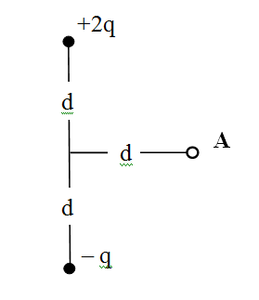

- At a certain distance from a point charge, the field intensity is 100V/m and the potential is 900V.

- The distance to the charge is… 5
A | B | C | D | E
7 m | 2 m | 3 m | 6 m | 9 m

The magnitude of the charge is…5
A | B | C | D | E
0.1 μC | 0.7 μC | 0.9 μC | 0.03 μC | 0.5 μC

- When a potential difference of 300 V is applied to the plates of a parallel-plate capacitor, the plates carry a surface charge density of 1.5·10^{–6}C/m². What is the spacing between the plates? (ε_{o}=8·10^{–12} C²/N·m²). 5
A | B | C | D | E
1.2 mm | 1.6 mm | 1.9 mm | 1.8 mm | 1.5 mm

…
- Two capacitors, C₁ = 5 μF and C₂ = 10 μF, are connected in parallel, and the resulting combination is connected to a 20 V battery. Find:
- the equivalent capacitance of the combination 5
A | B | C | D | E
5 μF | 12 μF | 10 μF | 15 μF | 2.4 μF

- the potential difference across each capacitor 5
A | B | C | D | E
10V, 15V | 50V, 50V | 40V, 60V | 100V, 100V | 20V, 20V

- the charge stored on each capacitor 5
A | B | C | D | E
0.4mC, 0.8mC | 0.4mC,  0.6mC | 100μC,  200μC | 80μC,  120μC | 200μC,  200μC

- A sphere with a radius of 0.25 m is charged to a potential of 30 000 V. Find the energy of the charged ball (π=3, ε_{o}=8·10^{–12} C²/N·m²). 5
A | B | C | D | E
216·10^{–4} J | 608·10^{–4} J | 502·10^{–4} J | 402·10^{–4} J | 108·10^{–4} J

- A parallel-plate capacitor with a plate separation d has a capacitance C_{o} in the absence of a dielectric. What is the capacitance when a slab of dielectric material of dielectric constant ε and thickness f·d is inserted between the plates, where f is a fraction between 0 and 1 (i.e. 0 $<$ f $<$ 1)? 5
.. 
- What work is performed when a point charge of 2·10^{–8}C is transferred from infinity to a point at a distance of 1 cm from the surface of a ball with a radius of 2 cm and a charge surface density of σ=2·10^{–4} C/m² (π=3, ε_{o}=8·10^{–12} C²/N·m²)? 5

- A closed surface with dimensions a=b=0.5 m and c = 2 m is located as shown in figure. The left edge of the closed surface is located at position x=a. The electric field throughout the region is non-uniform and is given by $\vec{E}$ = (2 + 4x²)·$\vec{i}$ N/C, where x is in meters.

a) Calculate the net electric flux leaving the closed surface; 5
b) What net charge is enclosed by the surface? 5


..
..

. A nichrome wire with a 0.5 mm cross-sectional radius is to be used in winding a heating coil. If 120 C of charge passes through the coil in 1 minute when a voltage of 240 V is applied across its ends (resistivity of the nichrome is ρ=1.2×10⁻⁶ Ω·m, π =3). Find the
a) required resistance of the coil 5…
A | B | C | D | E
120 Ω | 105 Ω | 100 Ω | 130 Ω | 125 Ω
b) length of wire you must use to make the coil. 5
A | B | C | D | E
50 m | 75 m | 100 m | 85 m | 65 m

2. A certain waffle iron is rated at 600 W (watt) when connected to a 120-V source.

- What current does the waffle iron carry? 5

A | B | C | D | E
3 A | 5 A | 4 A | 6 A | 2 A

b) What is its resistance? 5

A | B | C | D | E
32 Ω | 24 Ω | 44 Ω | 20 Ω | 34 Ω

3. Resistors R₁ = 2 Ω, R₂ = 6 Ω, R₃ = 4 Ω and R₄ = 1.6 Ω are connected in circuit as drawn shows…

- Find the equivalent resistance between points a and b in figure. 5

A | B | C | D | E
5.2 Ω | 8 Ω | 4 Ω | 6 Ω | 7 Ω

- Calculate the current in each resistor if a potential difference of 30 V is applied between points a and b. 5…

A | B | C | D | E
i₁=5A i₂=3A i₃=2A i₄=5A | i₁=5A i₂=2A i₃=3A i₄=5A | i₁=3A i₂=5A i₃=5A i₄=2A | i₁=2A i₂=3A i₃=2A i₄=3A | i₁=3A i₂=3A i₃=2A i₄=2A

4. An uncharged capacitor and a resistor are connected in series to a source of emf. If ξ = 5 V, C = 30 μF, and R = 50 Ω, (Euler's number e can be taken to equal 2.5.) find:

- the time constant Ƭ of the circuit; 5

A | B | C | D | E
3.2 ms | 2 ms | 1.5 ms | 2.5 ms | 2.8 ms

- the maximum charge on the capacitor; 5

A | B | C | D | E
162 μC | 125 μC | 130 μC | 185 μC | 150 μC

- the charge on the capacitor at a time equal to one time constant after the battery is connected. 5
A | B | C | D | E
90 μC | 100 μC | 80 μC | 118 μC | 105 μC

5. A 1μC point charge moves with a velocity of $\vec{v}$=(500$\vec{i}$ – 200$\vec{j}$) m/s in a region in which the magnetic field is $\vec{B}$ = 0.02$\vec{k}$ T. What is the magnitude of the magnetic force this particle experiences? 5

A | B | C | D | E
$\sqrt{101}$μN | $\sqrt{116}$ μN | 16 μN | $\sqrt{196}$ μN | 14 μN

6. The drawing shows a wire ab on the y-z plane with a I=1A current. Points a and b have coordinates (0, 3, 0)m and (0, 0, 2)m respectively. There is also a magnetic field B = 0.1 T that is the same everywhere and points in the direction of the +x axis. Find the components Fx, Fy and Fz of the force that acts on the wire. 5…
A | $\vec{F}$ (0; 0; 0.2)
B | $\vec{F}$ (0.2; -0.2; 0.3)
C | $\vec{F}$ (-0.2; 0.3; 0)
D | $\vec{F}$ (0.3; 0; 0.3)
E | $\vec{F}$ (0; -0.2; -0.3)

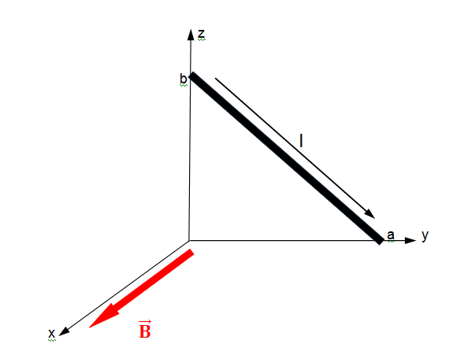

7. Two long, parallel wires carry currents of I₁ = 4 A and I₂ = 5 A in the directions indicated in figure. Find the magnitude and direction of the magnetic field at a point midway between the wires (d=2cm). 5
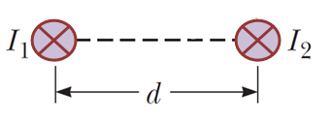
A | B | C | D | E
25 μT  upward | 20 μT  upward | 40 μT downward | zero | 25 μT downward

8. A cube of edge length a = 5 cm is positioned as shown in figure. A uniform magnetic field given by $\vec{B}$=(3$\vec{i}$ + 2$\vec{j}$ + 4$\vec{k}$) T exists throughout the region. Calculate the magnetic flux through the shaded face. 5
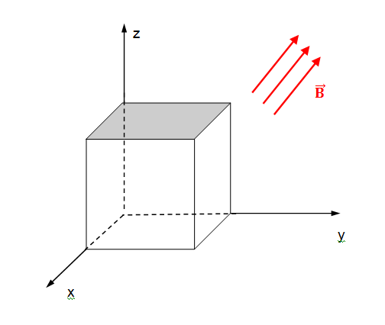
A | 11 mWb
B | 13 mWb
C | 12 mWb
D | 10 mWb
E | 9 mWb

9. A 1 m length of wire is held in an east–west direction and moves horizontally to the north with a speed of 0.2 m/s. The Earth’s magnetic field in this region is of magnitude 25 mT and is directed northward and θ=50º below the horizontal. Calculate the magnitude of the induced EMF between the ends of the wire. 5…
A | 8. 68 mV
B | zero
C | 4.32 mV
D | 5.96 mV
E | 3.83 mV



10. Consider the arrangement shown in figure. Assume that R = 2 Ω, L = 0.4 m, and a uniform 1.25 T magnetic field is directed into the page. At what speed $\vec{V}$ (in m/s) should the bar be moved to produce a current of 0.5 A in the resistor? 5

A | B | C | D | E
2 m/s | 1 m/s | 0.5 m/s | 0.2 m/s | 1.5 m/s

11. The magnetic flux through a metal ring varies with time t according to Φ_{B}=at³–bt² (Wb), where a = 3 Wb·s^{–3}, b = 9 Wb·s^{–2}, and t is in seconds. The resistance of the ring is 3 Ω.
Determine:

- EMF at t = 0.5 s; 5…

A | B | C | D | E
zero | 5.55 V | 6.75 V | 13.5 V | 1.5 V

- the current at t = 0.5 s; 5

- the maximum current induced in the ring. 5

9. In figure R₁ = 10 Ω, R₂ = 20 Ω, R₃ = 30 Ω, ξ₁ = 20 V and ξ₂ = 40 V.
Find:

a) the current in each resistor, 5
b) the power delivered to each resistor. 5

Bonus problem (20 points)
The circuit in figure is located in a magnetic field whose magnitude varies with time according to the expression B=10^{–3}·t, where B is in teslas and t is in seconds. Assume the resistance per length of the wire is 0.1 Ω/m. Find the current in section PQ of length a=50 cm.


- Charges +q and +2q are placed at (−a, 0) and (a, 0) respectively as shown in the figure. The coordinates of the point at which electric field intensity is zero will be (x, 0), where 5

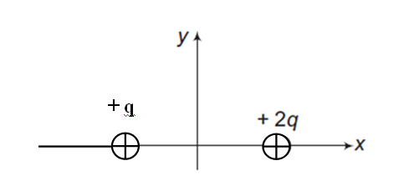
A | B | C | D | E
x < − 2a | − 2a < x < −a | −a < x < a | a < x < 2a | x $>$ 3a

- Two point charges q₁ and q₂ are placed in oil whose relative permittivity is ε=9 at a distance of 21 cm from each other, and interact with a certain force. The same charges are now put in air. If the interacting force between them is still the same, their separation now is 5
A | B | C | D | E
36.9 cm | 42.0 cm | 84.3 cm | 63.0 cm | 21.0 cm

- Two identical small conducting spheres having equal charges +q and –q are separated by a distance r. If they are now made to touch each other and then separated again to the same distance, the electrostatic force between them in this case will be 5
A | B | C | D | E
more than before | zero | will diminish twofold | same as before | less than before

- The electric field in a region of space is given by $\vec{E}$= 5$\vec{i}$ + 8$\vec{j}$ N/C. The flux of $\vec{E}$ due to this field through an area 0.5 m² lying in the x-y plane, in V·m units, is 5
A | B | C | D | E
4 | 11 | 29 | 2 | 0

- The surface charge density of uniformly charged filament is σ = 36·10^{–9}C/m². Calculate the magnitude of the electric field intensity produced by the surface in vacuum (ε_{o}=9·10^{–12} C²/N·m²). 5
A | B | C | D | E
5 kN/C | 3 kN/C | 500 N/C | 2 kN/C | 4 kN/C

- A uniform electric field of magnitude 0.5·10³ V/m is perpendicular to a square sheet with sides 2 m long. What is the electric flux through the sheet? 5

A | B | C | D | E
6·10³ V·m | 2·10³ V·m | 2.2·10³ V·m | 10³ V·m | 4.5·10³ V·m

- Calculate the flux through the sheet of the previous problem (ques.6) if the plane of the sheet is at an angle of 30° to the field. Find the flux for both directions of the unit normal to the sheet. 5

A | B | C | D | E
5·10³ V·m | 2.25·10³ V·m | 4·10³ V·m | 0.6·10³ V·m | 10³ V·m

- A charge Q is located inside a rectangular box. The electric flux through each of the six surfaces of the box is: Φ₁=+3400V·m, Φ₂=+3000V·m, Φ₃=+4600V·m, Φ₄= –1800V·m, Φ₅= –2500V·m, and Φ₆= –5200V·m. What is Q? (ε_{o}=8·10^{–12} C²/N·m²) 5

A | B | C | D | E
- 4 nC | 14 nC | - 16 nC | 12 nC | 2 nC

- What is the total electric potential at point A, as shown in figure? 5
A | – $\frac{k·q}{d}$
B | $$\frac{k·q}{d\sqrt{2}}$$
C | $$\frac{k·2q}{d}$$
D | – $\frac{k·q}{d\sqrt{2}}$
E | zero

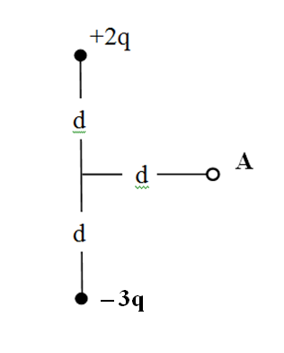

- At a certain distance from a point charge, the field intensity is 100V/m and the potential is 9V.

- The distance to the charge is… 5
A | B | C | D | E
7 cm | 2 cm | 3 cm | 6 cm | 9 cm

The magnitude of the charge is…5
A | B | C | D | E
0.1 μC | 0.7 nC | 90 pC | 0.03 pC | 0.5 nC

- When a potential difference of 300 V is applied to the plates of a parallel-plate capacitor, the plates carry a surface charge density of 1.5·10^{–6}C/m². What is the spacing between the plates? (ε_{o}=8·10^{–12} C²/N·m²). 5
A | B | C | D | E
1.2 mm | 1.6 mm | 1.9 mm | 1.8 mm | 1.5 mm

- Two capacitors, C₁ = 5 μF and C₂ = 10 μF, are connected in parallel, and the resulting combination is connected to a 20 V battery. Find:
- the equivalent capacitance of the combination 5
A | B | C | D | E
5 μF | 12 μF | 10 μF | 15 μF | 2.4 μF

- the potential difference across each capacitor 5
A | B | C | D | E
10V, 15V | 50V, 50V | 40V, 60V | 100V, 100V | 20V, 20V

- the charge stored on each capacitor 5
A | B | C | D | E
0.4mC, 0.8mC | 0.4mC,  0.6mC | 100μC,  200μC | 80μC,  120μC | 200μC,  200μC

- A sphere with a diameter of 0.5 m is charged to a potential of 30 000 V. Find the energy of the charged ball (π=3, ε_{o}=8·10^{–12} C²/N·m²). 5
A | B | C | D | E
216·10^{–4} J | 608·10^{–4} J | 502·10^{–4} J | 402·10^{–4} J | 108·10^{–4} J

- A parallel-plate capacitor with plate area A has a capacitance C_{o} in the absence of a dielectric. What is the capacitance when a slab of dielectric material of dielectric constant ε and cross-sectional area f·A is inserted between the plates, where f is a fraction between 0 and 1 (i.e. 0 $<$ f $<$ 1)? 5
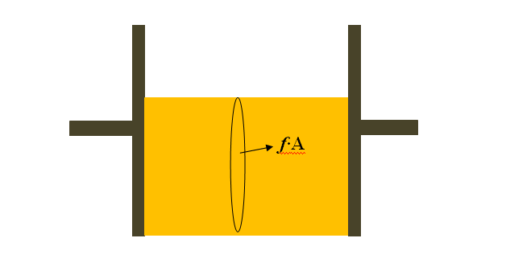

- The potential at location A is 452 V. A positively charged particle is released there from rest and arrives at location B with a speed v_{B.} The potential at location C is 791 V, and when released from this spot, the particle arrives at B with twice the speed it previously had, or 2v_{B}. Find the potential at B. 5

- A closed surface with dimensions a=b=0.5 m and c = 1 m is located as shown in figure. The left edge of the closed surface is located at position x=a. The electric field throughout the region is non-uniform and is given by $\vec{E}$ = (2x+x²)·$\vec{i}$ N/C, where x is in meters.

a) Calculate the net electric flux leaving the closed surface; 5
b) What net charge is enclosed by the surface? 5

.. 

- A small plastic ball of mass m is suspended by a long string in a uniform electric field $\vec{E}$ as shown in figure. If the ball is in equilibrium when the string makes a φ angle with the vertical, express…@


- the net charge on the ball? -5-

- the tension in the thread? -5-

in terms m, E, and φ.

- The drawing shows an edge-on view of two planar surfaces that intersect and are mutually perpendicular. Surface 1 has an area of A₁ = 3 m², while surface 2 has an area of A₂ = 4 m². The electric field in the drawing is uniform and has a magnitude of E=150 N/C (θ=60°). Find the magnitude of the electric flux through



a) surface 1 -5-

b) surface 2 -5-

3. A sphere with a radius of 0.5 m is charged to a potential of 40000 V (π=3, ε_{o}=8·10^{–12} C²/N·m²). Find the: @

- energy of the charged ball W -5-

- surface charge density σ. -5-

- Consider the circuit shown in figure where R₁ = 10 Ω, R₂ = 5 Ω, R₃ = 10 Ω, R₄ = 3 Ω, R₅ = 2 Ω, and ε = 60 V Find:
a) the current in the R₂ resistor; -5-

b) the potential difference between points -5-
a and b.



- A particle has a charge of +1 mC and is located at the coordinate origin. As the drawing shows, an electric field of E_{x} = 200 V/m exists along the +x axis. A magnetic field also exists, and its components are B_{x} = 2 T and B_{y} = 1 T. Calculate the magnitude of the force exerted on the particle by each of the three fields when it is: @
- stationary, -5-
- moving along the “– z” axis at a speed of 200 m/s. -5-


- The drawing shows a wire of length l (a = 50cm, b = 60 cm) with a current I = 10 A lying in x-y plane. There is also a homogeneous magnetic field $\vec{B}$ = 0.4·$\vec{j}$ + 0.6·$\vec{k}$ (T). Find the components F_{x}, F_{y} and F_{z} of the force that acts on the wire. -10-


- A constant magnetic field passes through a single rectangular loop whose dimensions are 0.4m×0.5m. The magnetic field has a magnitude of 1.5 T and is perpendicular to the plane of the loop. @

- If the magnetic field decreases to zero in a time of 0.4 s, what is the magnitude of the average EMF induced in the loop? -5-

- If the magnetic field remains constant at its initial value of 1.5 T, what is the magnitude of the rate at which the area should change so that the average EMF has the same magnitude as in part (a)? -5-

- The equation of the change with time of the current in a circuit is given as i= – 0.6·sin(250·π·t) (amper). The Inductance of the circuit is L = 2 H.
Find:
- the period of oscillations; -5-

- the maximum energy of the electric field. -5-

9. A series RLC circuit has a resistance of R=150 Ω and an impedance of Z=200 Ω. @

a) What average power is delivered to this circuit when U_{rms} = 200 V?
-5-

b) Find the tangent of the phase angle tanφ. -5-

- When the light ray illustrated in figure passes through the glass block of index of refraction n=1.5, it is shifted laterally by the distance d (H=40mm, θ=45°, light speed in vacuum is c=3·10⁸ m/s). The solution can be represented in symbols, getting the final solution expressed in given values.

a) Find the value of d. -5-

b) Find the time interval required for the light to pass through the glass block. -5-



. A nichrome wire with a 0.5 mm cross-sectional radius is to be used in winding a heating coil. If 120 C of charge passes through the coil in 1 minute when a voltage of 240 V is applied across its ends (resistivity of the nichrome is ρ=1.2×10⁻⁶ Ω·m, π =3). Find the
a) required resistance of the coil 5….
A | B | C | D | E
105 Ω | 120 Ω | 100 Ω | 130 Ω | 125 Ω
b) length of wire you must use to make the coil. 5
A | B | C | D | E
50 m | 85 m | 100 m | 75 m | 65 m

2. A certain waffle iron is rated at 600 W (watt) when connected to a 120-V source.

- What current does the waffle iron carry? 5

A | B | C | D | E
5 A | 3 A | 4 A | 6 A | 2 A

b) What is its resistance? 5

A | B | C | D | E
32 Ω | 54 Ω | 24 Ω | 20 Ω | 34 Ω

3. Resistors R₁ = 2 Ω, R₂ = 6 Ω, R₃ = 4 Ω and R₄ = 1.6 Ω are connected in circuit as drawn shows…

- Find the equivalent resistance between points a and b in figure. 5

A | B | C | D | E
5.2 Ω | 6 Ω | 4.1 Ω | 8 Ω | 7 Ω

- Calculate the current in each resistor if a potential difference of 30 V is applied between points a and b. 5….

A | B | C | D | E
i₁=5A i₂=3A i₃=2A i₄=5A | i₁=5A i₂=6A i₃=4A i₄=5A | i₁=3A i₂=5A i₃=5A i₄=2A | i₁=2A i₂=3A i₃=2A i₄=3A | i₁=5A i₂=2A i₃=3A i₄=5A

4. An uncharged capacitor and a resistor are connected in series to a source of emf. If ξ = 5 V, C = 30 μF, and R = 50 Ω, (Euler's number e can be taken to equal 2.5.) find:

- the time constant Ƭ of the circuit; 5

A | B | C | D | E
3.2 ms | 2 ms | 2.5 ms | 1.5 ms | 2.8 ms

- the maximum charge on the capacitor; 5

A | B | C | D | E
162 μC | 125 μC | 150 μC | 185 μC | 130 μC

- the charge on the capacitor at a time equal to one time constant after the battery is connected. 5
A | B | C | D | E
95 μC | 90 μC | 80 μC | 118 μC | 105 μC

5. A 1μC point charge moves with a velocity of $\vec{v}$=(500$\vec{i}$ – 200$\vec{j}$) m/s in a region in which the magnetic field is $\vec{B}$ = 0.02$\vec{k}$ T. What is the magnitude of the magnetic force this particle experiences? 5

A | B | C | D | E
$\sqrt{101}$μN | $\sqrt{196}$ μN | 16 μN | $\sqrt{116}$ μN | 14 μN

6. The drawing shows a wire ab on the y-z plane with a I=1A current. Points a and b have coordinates (0, 3, 0)m and (0, 0, 2)m respectively. There is also a magnetic field B = 0.1 T that is the same everywhere and points in the direction of the +x axis. Find the components Fx, Fy and Fz of the force that acts on the wire. 5….
A | $\vec{F}$ (0; 0; 0.2)
B | $\vec{F}$ (0; -0.2; -0.3)
C | $\vec{F}$ (-0.2; 0.3; 0)
D | $\vec{F}$ (0.3; 0; 0.3)
E | $\vec{F}$ (0; -2; 0)



7. Two long, parallel wires carry currents of I₁ = 7 A and I₂ = 8 A in the directions indicated in figure. Find the magnitude and direction of the magnetic field at a point midway between the wires (d=2cm). 5

A | B | C | D | E
20 μT  upward | 27 μT  upward | 40 μT downward | zero | 27 μT downward

8. A cube of edge length a = 5 cm is positioned as shown in figure. A uniform magnetic field given by $\vec{B}$=(3$\vec{i}$ + 2$\vec{j}$ + 4$\vec{k}$) T exists throughout the region. Calculate the magnetic flux through the shaded face. 5

A | 11 mWb
B | 13 mWb
C | 10 mWb
D | 12 mWb
E | 9 mWb

9. A 1 m length of wire is held in an east–west direction and moves horizontally to the north with a speed of 0.2 m/s. The Earth’s magnetic field in this region is of magnitude 25 mT and is directed northward and θ=50º below the horizontal. Calculate the magnitude of the induced EMF between the ends of the wire. 5….
A | 8. 68 mV
B | 3.83 mV
C | 4.32 mV
D | 5.96 mV
E | zero



10. Consider the arrangement shown in figure. Assume that R = 2 Ω, L = 0.4 m, and a uniform 1.25 T magnetic field is directed into the page. At what speed $\vec{V}$ (in m/s) should the bar be moved to produce a current of 0.5 A in the resistor? 5

A | B | C | D | E
0.8 m/s | 1 m/s | 0.5 m/s | 2 m/s | 1.5 m/s

11. The magnetic flux through a metal ring varies with time t according to Φ_{B}=at³–bt² (Wb), where a = 3 Wb·s^{–3}, b = 9 Wb·s^{–2}, and t is in seconds. The resistance of the ring is 3 Ω.
Determine:

- EMF at t = 0.5 s; 5

A | B | C | D | E
zero | 5.55 V | 1.75 V | 13.5 V | 6.75 V

- the current at t = 0.5 s; 5

- the maximum current induced in the ring. 5

9. In figure R₁ = 10 Ω, R₂ = 20 Ω, R₃ = 30 Ω, ξ₁ = 20 V and ξ₂ = 40 V….
Find:

a) the current in each resistor, 5
b) the power delivered to each resistor. 5

Bonus problem (20 points)
The circuit in figure is located in a magnetic field whose magnitude varies with time according to the expression B=10^{–3}·t, where B is in teslas and t is in seconds. Assume the resistance per length of the wire is 0.1 Ω/m. Find the current in section PQ of length a=50 cm.


1. A nichrome wire with a 0.1 mm cross-sectional radius is to be used in winding a heating coil. If 12 C of charge passes through the coil in 20 seconds when a voltage of 24 V is applied across its ends (resistivity of the nichrome is ρ=1.2×10⁻⁶ Ω·m, π =3). Find the
a) required resistance of the coil 5…..
A | B | C | D | E
10 Ω | 20 Ω | 48 Ω | 40 Ω | 25 Ω
b) length of wire you must use to make the coil. 5
A | B | C | D | E
5 m | 1 m | 2 m | 4 m | 3 m

2. A certain waffle iron is rated at 60 W (watt) when connected to a 120-V source.

- What current does the waffle iron carry? 5

A | B | C | D | E
0.2 A | 0.3 A | 0.4 A | 0.6 A | 0.5 A

b) What is its resistance? 5

A | B | C | D | E
320 Ω | 540 Ω | 240 Ω | 200 Ω | 340 Ω

3. Resistors R₁ = 2 Ω, R₂ = 2 Ω, R₃ = 8 Ω and R₄ = 1.4 Ω are connected in circuit as drawn shows…

- Find the equivalent resistance between points a and b in figure. 5

A | B | C | D | E
5 Ω | 6 Ω | 4.1 Ω | 8 Ω | 7 Ω

- Calculate the current in each resistor if a potential difference of 50 V is applied between points a and b. 5…..

A | B | C | D | E
i₁=10A i₂=6A i₃=4A i₄=10A | i₁=10A i₂=5A i₃=5A i₄=10A | i₁=10A i₂=2A i₃=8A i₄=10A | i₁=10A i₂=8A i₃=2A i₄=10A | i₁=10A i₂=10A i₃=10A i₄=10A

4. An uncharged capacitor and a resistor are connected in series to a source of emf. If ξ = 5 V, C = 10 μF, and R = 30 Ω, (Euler's number e can be taken to equal 2.5.) find:

- the time constant Ƭ of the circuit; 5

A | B | C | D | E
0.2 ms | 0.3 ms | 0.5 ms | 1.5 ms | 0.8 ms

- the maximum charge on the capacitor; 5

A | B | C | D | E
62 μC | 25 μC | 50 μC | 85 μC | 30 μC

- the charge on the capacitor at a time equal to one time constant after the battery is connected. 5
A | B | C | D | E
35 μC | 30 μC | 40 μC | 48 μC | 45 μC

5. A 1μC point charge moves with a velocity of $\vec{v}$=(500$\vec{i}$ + 200$\vec{j}$) m/s in a region in which the magnetic field is $\vec{B}$ = 0.01$\vec{k}$ T. What is the magnitude of the magnetic force this particle experiences? 5

A | B | C | D | E
$\sqrt{29}$μN | $\sqrt{26}$ μN | 11 μN | $\sqrt{116}$ μN | 14 μN

6. The drawing shows a wire ab on the y-z plane with a I=1A current. Points a and b have coordinates (0, 3, 0)m and (0, 0, 2)m respectively. There is also a magnetic field B = 0.1 T that is the same everywhere and points in the direction of the +x axis. Find the components Fx, Fy and Fz of the force that acts on the wire. 5…..
A | $\vec{F}$ (0; 0; –0.2)
B | $\vec{F}$ (0; 0.2; 0.3)
C | $\vec{F}$ (–0.2; –0.3; 0)
D | $\vec{F}$ (–0.3; 0; 0.3)
E | $\vec{F}$ (0; –2; 0)

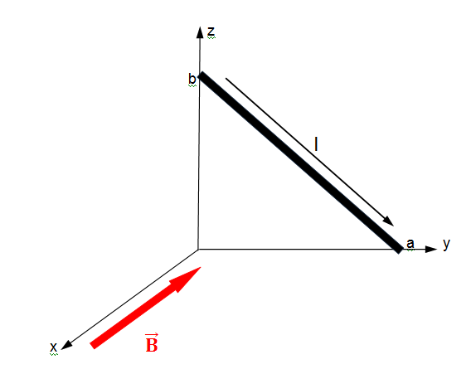

7. Two long, parallel wires carry currents of I₁ = 7 A and I₂ = 7 A in the directions indicated in figure. Find the magnitude and direction of the magnetic field at a point midway between the wires (d=2cm). 5

A | B | C | D | E
20 μT  upward | 27 μT  upward | 40 μT downward | zero | 27 μT downward

8. A cube of edge length a = 10 cm is positioned as shown in figure. A uniform magnetic field given by $\vec{B}$=(3$\vec{i}$ + 2$\vec{j}$ + 1$\vec{k}$) T exists throughout the region. Calculate the magnetic flux through the shaded face. 5

A | 11 mWb
B | 13 mWb
C | 10 mWb
D | 12 mWb
E | 9 mWb

9. A 0.5 m length of wire is held in an east–west direction and moves horizontally to the north with a speed of 0.4 m/s. The Earth’s magnetic field in this region is of magnitude 25 mT and is directed northward and θ=50º below the horizontal. Calculate the magnitude of the induced EMF between the ends of the wire. 5…..
A | 8. 68 mV
B | 3.83 mV
C | 4.32 mV
D | 5.96 mV
E | zero



10. Consider the arrangement shown in figure. Assume that R = 2 Ω, L = 0.4 m, and a uniform 12.5 T magnetic field is directed into the page. At what speed $\vec{V}$ (in m/s) should the bar be moved to produce a current of 0.5 A in the resistor? 5

A | B | C | D | E
0.8 m/s | 0.2 m/s | 0.5 m/s | 0.4 m/s | 1.5 m/s

11. The magnetic flux through a metal ring varies with time t according to Φ_{B}=at³–bt² (Wb), where a = 3 Wb·s^{–3}, b = 9 Wb·s^{–2}, and t is in seconds. The resistance of the ring is 3 Ω.
Determine:

- EMF at t = 0.5 s; 5

A | B | C | D | E
zero | 6.75 V | 1.75 V | 13.5 V | 5.55 V

- the current at t = 0.5 s; 5

- the maximum current induced in the ring. 5

9. In figure R₁ = 10 Ω, R₂ = 20 Ω, R₃ = 30 Ω, ξ₁ = 20 V and ξ₂ = 40 V…..
Find:

a) the current in each resistor, 5
b) the power delivered to each resistor. 5

Bonus problem (20 points)
The circuit in figure is located in a magnetic field whose magnitude varies with time according to the expression B=10^{–3}·t, where B is in teslas and t is in seconds. Assume the resistance per length of the wire is 0.1 Ω/m. Find the current in section PQ of length a=50 cm.


1. A nichrome wire with a 1 mm cross-sectional radius is to be used in winding a heating coil. If 120 C of charge passes through the coil in 2 minutes when a voltage of 30 V is applied across its ends (resistivity of the nichrome is ρ=1.5×10⁻⁶ Ω·m, π =3). Find the
a) required resistance of the coil 5.
A | B | C | D | E
30 Ω | 35 Ω | 25 Ω | 40 Ω | 45 Ω
b) length of wire you must use to make the coil. 5
A | B | C | D | E
50 m | 60 m | 55 m | 65 m | 58 m

2. A certain waffle iron is rated at 1.1 kW (kilowatt) when connected to a 5-A source.

- What is the voltage? 5

A | B | C | D | E
240 V | 200 V | 110 V | 220 V | 120 V

b) What is its resistance? 5

A | B | C | D | E
52 Ω | 55 Ω | 34 Ω | 60 Ω | 44 Ω

3. Resistors R₁ = 4 Ω, R₂ = 6 Ω, R₃ = 5.5 Ω, R₄ = 3 Ω, and R₅ = 7 Ω are connected in circuit as drawn shows…
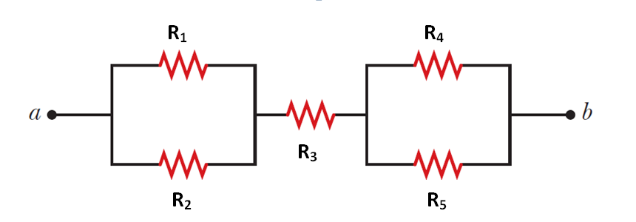
- Find the equivalent resistance between points a and b in figure. 5

A | B | C | D | E
8 Ω | 12 Ω | 14 Ω | 6 Ω | 10 Ω

- Calculate the current in each resistor if a potential difference of 10 V is applied between points a and b. 5.

A | B | C | D | E
i₁=0.4A i₂=0.6A i₃= 1 A i₄=0.3A  i₅=0.7A | i₁=0.5A i₂=0.5A i₃= 1 A i₄=0.5A  i₅=0.5A | i₁=0.6A i₂=0.4A i₃=0.4A i₄=0.3A  i₅=0.3A | i₁=0.6A i₂=0.4A i₃= 1 A i₄=0.7A  i₅=0.3A | i₁=0.8A i₂=0.2A i₃= 1 A i₄=0.1A  i₅=0.9A

4. A charged capacitor and a resistor are connected in series to a source of emf. If ξ = 90 V, the resistance R = 2000 Ω, and time constant Ƭ = 4 ms (Euler's number e can be taken to equal 2.5.) find:

- the capacitance C of the circuit; 5

A | B | C | D | E
3 μF | 4 μF | 2 μF | 1.5 μF | 2.5 μF

- the maximum charge on the capacitor; 5

A | B | C | D | E
180 μC | 175 μC | 160 μC | 185 μC | 190 μC

- the charge on the capacitor at a time equal to one time constant after the capacitor starts to discharge. 5

A | B | C | D | E
110 μC | 105 μC | 62 μC | 72 μC | 79 μC

5. A 1μC point charge moves with a velocity of $\vec{v}$=(40$\vec{i}$ +20$\vec{j}$) m/s in a region in which the magnetic field is $\vec{B}$ = (0.3$\vec{i}$ + 0.2$\vec{j}$) T. What is the magnitude of the magnetic force this particle experiences? 5

A | B | C | D | E
10 μN | 2 μN | 6 μN | 14 μN | 0.5 μN

6. The drawing shows a wire ab on the y-z plane with a I=2A current. Points a and b have coordinates (0, 4, 0)m and (0, 0, 5)m respectively. There is also a magnetic field B = 0.5 T that is the same everywhere and points in the direction of the +x axis. Find the components Fx, Fy and Fz of the force that acts on the wire. 5.

7. Two long, parallel wires carry currents of I₁ = 0.5 A and I₂ = 0.5 A in the directions indicated in figure. Find the magnitude and direction of the magnetic field at a point midway between the wires (d=2cm). 5

A | B | C | D | E
25 μT  upward | 30 μT  upward | 40 μT downward | zero | 25 μT downward

8. A cube of edge length a = 2 cm is positioned as shown in figure. A uniform magnetic field given by $\vec{B}$= (4$\vec{i}$ + 3$\vec{j}$ + 5$\vec{k}$) T exists throughout the region. Calculate the magnetic flux through the shaded face. 5

9. A 2 m length of wire is held in an east–west direction and moves horizontally to the north with a speed of 0.5 m/s. The Earth’s magnetic field in this region is of magnitude 50 mT and is directed northward and θ=55º below the horizontal. Calculate the magnitude of the induced EMF between the ends of the wire. 5.
A | 28. 68 mV
B | 35.00 mV
C | 48.32 mV
D | 40.96 mV
E | zero



10. Consider the arrangement shown in figure. Assume that R = 8 Ω, L = 1.6 m, and a uniform 2.5 T magnetic field is directed into the page. At what speed $\vec{V}$ (in m/s) should the bar be moved to produce a current of 0.5 A in the resistor? 5

A | B | C | D | E
2 | 1.2 | 0.5 | 0.4 | 1

11. The magnetic flux through a metal ring varies with time t according to Φ_{B}=at³–bt² (Wb), where a = 6 Wb·s^{–3}, b = 18 Wb·s^{–2}, and t is in seconds. The resistance of the ring is 3 Ω.
Determine:

- EMF at t = 0.5 s; 5

A | B | C | D | E
zero | 5.5 V | 2 V | 13.5 V | 15 V

- the current at t = 0.5 s; 5

- the maximum current induced in the ring. 5

12. Find:
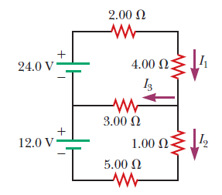
a) the current in each resistor, 5
b) the power delivered to each resistor. 5

Bonus problem (20 points)

A material of resistivity ρ is formed into the shape of a truncated cone of height h as shown in figure. The bottom end has radius b, and the top end has radius a. Assume the current is distributed uniformly over any circular cross section of the cone so that the current density does not depend on radial position. (The current density does vary with position along the axis of the cone.) Find the resistance between the two ends…

